Dear Parents and Guardians,
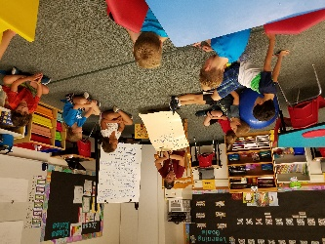
We have had a wonderful start to the school year. Teachers have worked to assist children in learning classroom expectations and routines. Using interactive modeling, a Responsive Classroom technique, teachers are ensuring that all students understand the steps involved in lining up, sitting in circle, listening to a speaker, working in groups and much more. While students continue to practice these skills, they have shown great progress in setting the stage for a safe and respectful classroom environment.
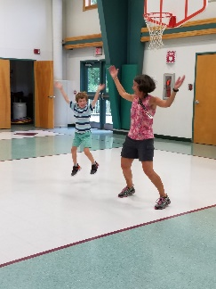
Open House is scheduled for Wednesday September 26th from 6pm - 7pm. Open House is an opportunity to learn more about the classroom curriculum as well as see the wonderful work your children have accomplished over the first few weeks of school. Please join us in celebrating the HES students’ accomplishments thus far!
We are lucky to have an additional staff member for the first quarter of the school year. Jeanie West, former teacher, assistant principal and principal in the district, will be working with students and teachers to create engaging academic literacy centers for the classrooms. She will also work in small groups with some students during WIN (What I Need) time.
Next week we will begin our fall benchmark assessments. The information gained from the assessments will assist teachers with identify areas of academic strength. Teachers will also use the information to identify instructional focus for math and literacy for the next 6 – 8 weeks. Please see the attached document that further explains the assessments.
PTO will be holding their first meeting for the year. Please join us in the HES library on Thursday, September 20th at 6PM. We hope that our meetings may serve both as a support for families as well as a support for the school. A teacher and administrator attend each meeting and can answer any questions that you might have regarding practices at HES.
The Boys and Girls Club is off to a good start. We have a few students who attend the morning program and a different group that attends in the afternoon. I know that the bus ride is a bit long in the afternoon. Thank you for your patience as we work through routes and determine the best options for getting the children to the program quickly and safely.
“The School District needs your assistance and input. The School District is looking for parents who can dedicate up to 8 hours weekly to examine how we might operationalize a proposed consolidation that will appear as a warrant article for the community to consider on the 2019 warrant in March. If you are interested please forward your school principal your name.”
Our special next week is Music with Ms. Pineau.
Have a wonderful weekend!

