Happy Thanksgiving!
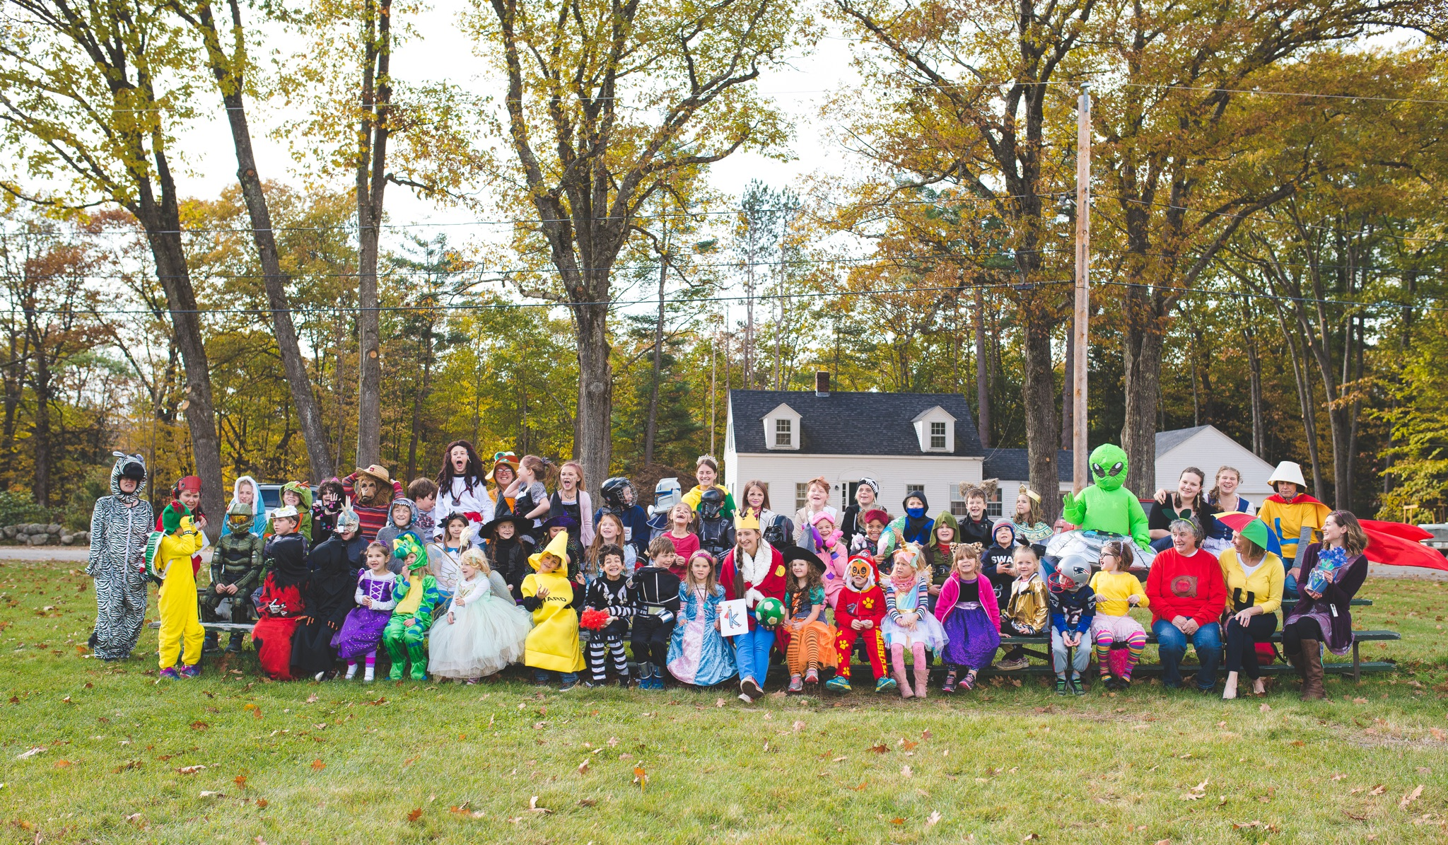
There is so much to be thankful for this holiday season. I am thankful for the support you provide students and staff. It is because of you that we have had a wonderful start to the school year. I am thankful for the staff who work tirelessly to ensure all children learn and grow into strong community members. I am thankful for people behind the scenes that attend to paperwork, lunch counts and keep the school in tiptop shape. And, most of all, I am truly grateful for the wonderful children at HES. I feel so fortunate to be a part of such a supportive and caring community.
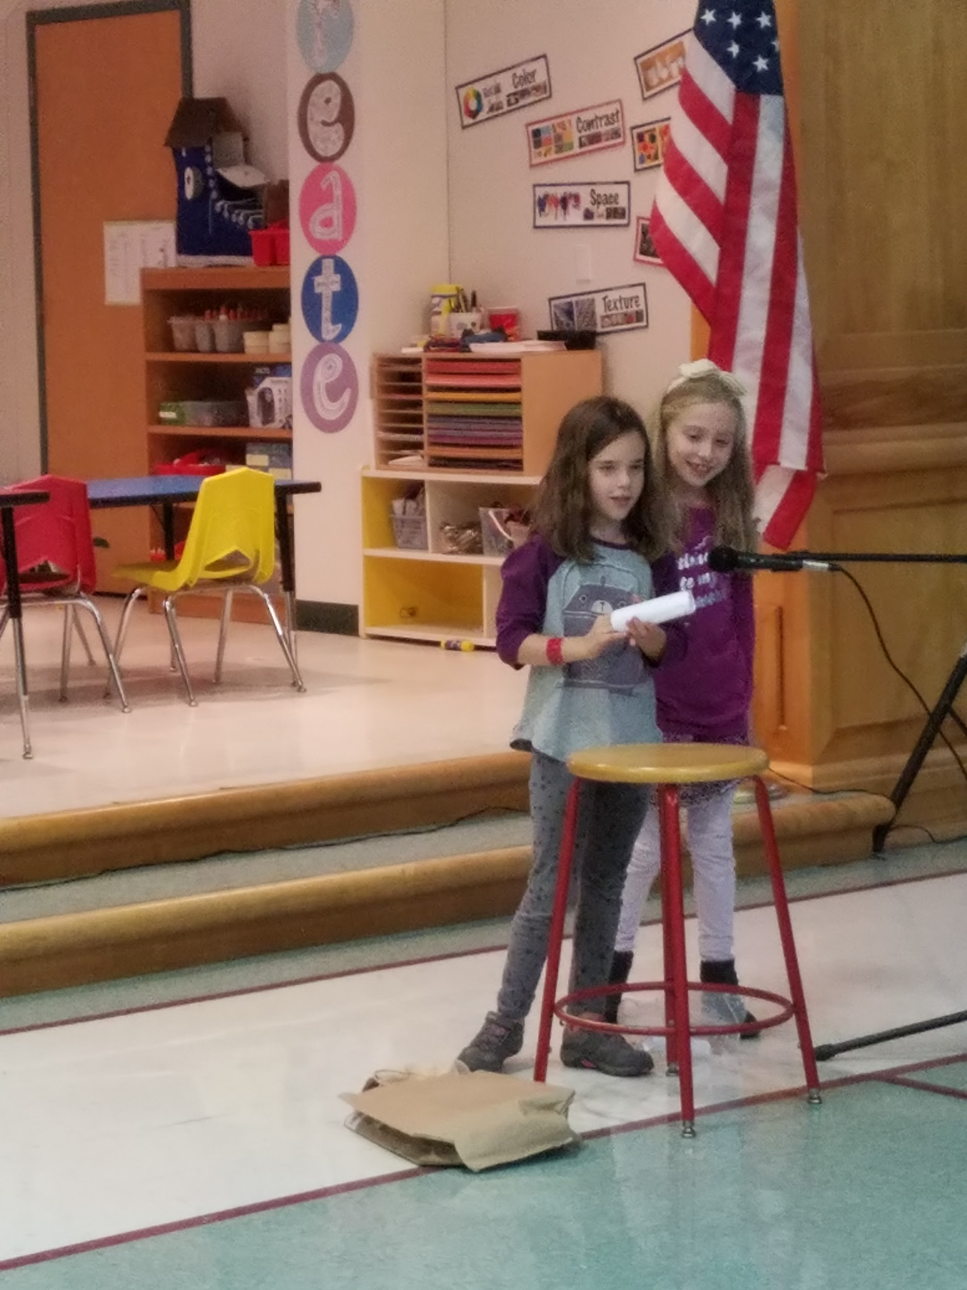
I want to publicly thank Ms. Hutchins, Ms. Carter, and Mr. Sutherland for organizing and executing the HES Talent Show. The children were so excited and proud of themselves and each other. We saw a range of talents including dance/gymnastics, magic tricks, obstacle courses, lip syncing, book making, karate, hula hooping and singing. Who knew we had such talent among our community! Thank you to families and friends who came to the fabulous performance.
I also want to thank Mrs. Parker for organizing the turkey trot. The winds were whipping but children managed to walk or run at least a mile. After running, we headed to GES to eat our snacks and draw the winning names for the turkey. Thank you all for your donations of dry goods for the SMS Food Pantry.
We are well into snow season. Please remember to send your children with snow pants, mittens, hat, boots and a snow jacket. Unless the feels like temperature falls below 10 degrees, the children will be outside enjoying the fresh air.
An orderly routine at dismissal is critical for the safety of all students. Children need everyone’s help learning how to be safe around moving vehicles. Parents can help by following these safety routines:
1. Buses are loaded and dismissed first. NEVER PASS WAITING BUSES. Occasionally the teacher on duty may need to board a bus to speak with the driver or the students – please be patient in the event of a delay, and remember that safety must come first.
2. Cars wait in a single line until all buses have boarded and departed. DO NOT PARK IN THE PICKUP LINE OR LEAVE YOUR VEHICLE UNATTENDED. Please stay in your vehicle until the teacher on duty dismisses your child. DO NOT PASS WAITING CARS. Students will be dismissed by the side door facing the parking lot. Please note that car pickups are only permitted in the main parking lot (no School Street car pickups). Children may not run between buses or cars waiting in the pickup line. Please ask a staff member for assistance so the line of pickup cars can be safely stopped while you and your child walk to your car. We recommend holding young children by the hand.
If a staff member reminds you of the procedure, please do not be offended. They are simply ensuring the safety of all.
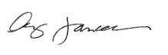
Have a wonderful Thanksgiving!

