Happy Columbus Day to all!
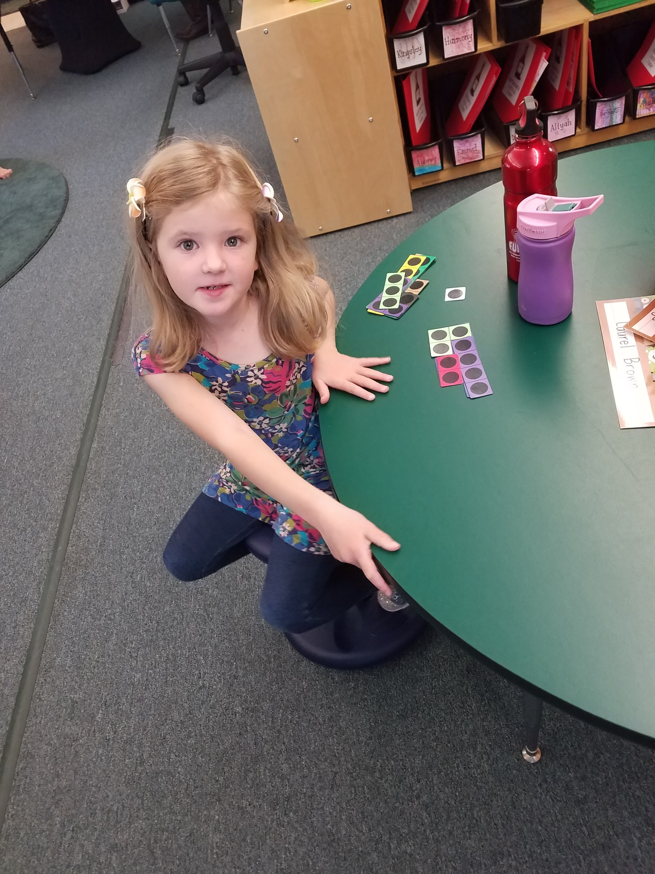
Have you heard about the Letterlanders!? Letterlanders are the characters that live in Letterland. They have lovely songs and memorable actions that help kindergarteners and first graders remember the sounds of the letters in the alphabet as well as read words. Last Friday at assembly, our first graders taught the 2nd, 3rd, and 4th graders about some of the characters. They did a wonderful job sharing their knowledge. Please join us for our next assembly on Friday, October 19th at 11:30 am to see what 2nd grade will share.
Just a friendly reminder to sign up for donations for the Harvest Feast. Also, please be sure to invite friends and neighbors to the event on Thursday, October 25th from 5:30 - 7:00 pm. We all love connecting with the community at this event. In keeping with World Food Day, please inform guests to bring their own bowl, cloth napkin and spoon.
Speaking of food, the second graders worked with Cornucopia last week to answer the following question, “How do we know when it's fall?" The rain did not stop everyone from having tons of fun digging up potatoes! While some dug up potatoes, others played a matching game using paint color samples to match to a variety of colorful specimens from the garden.
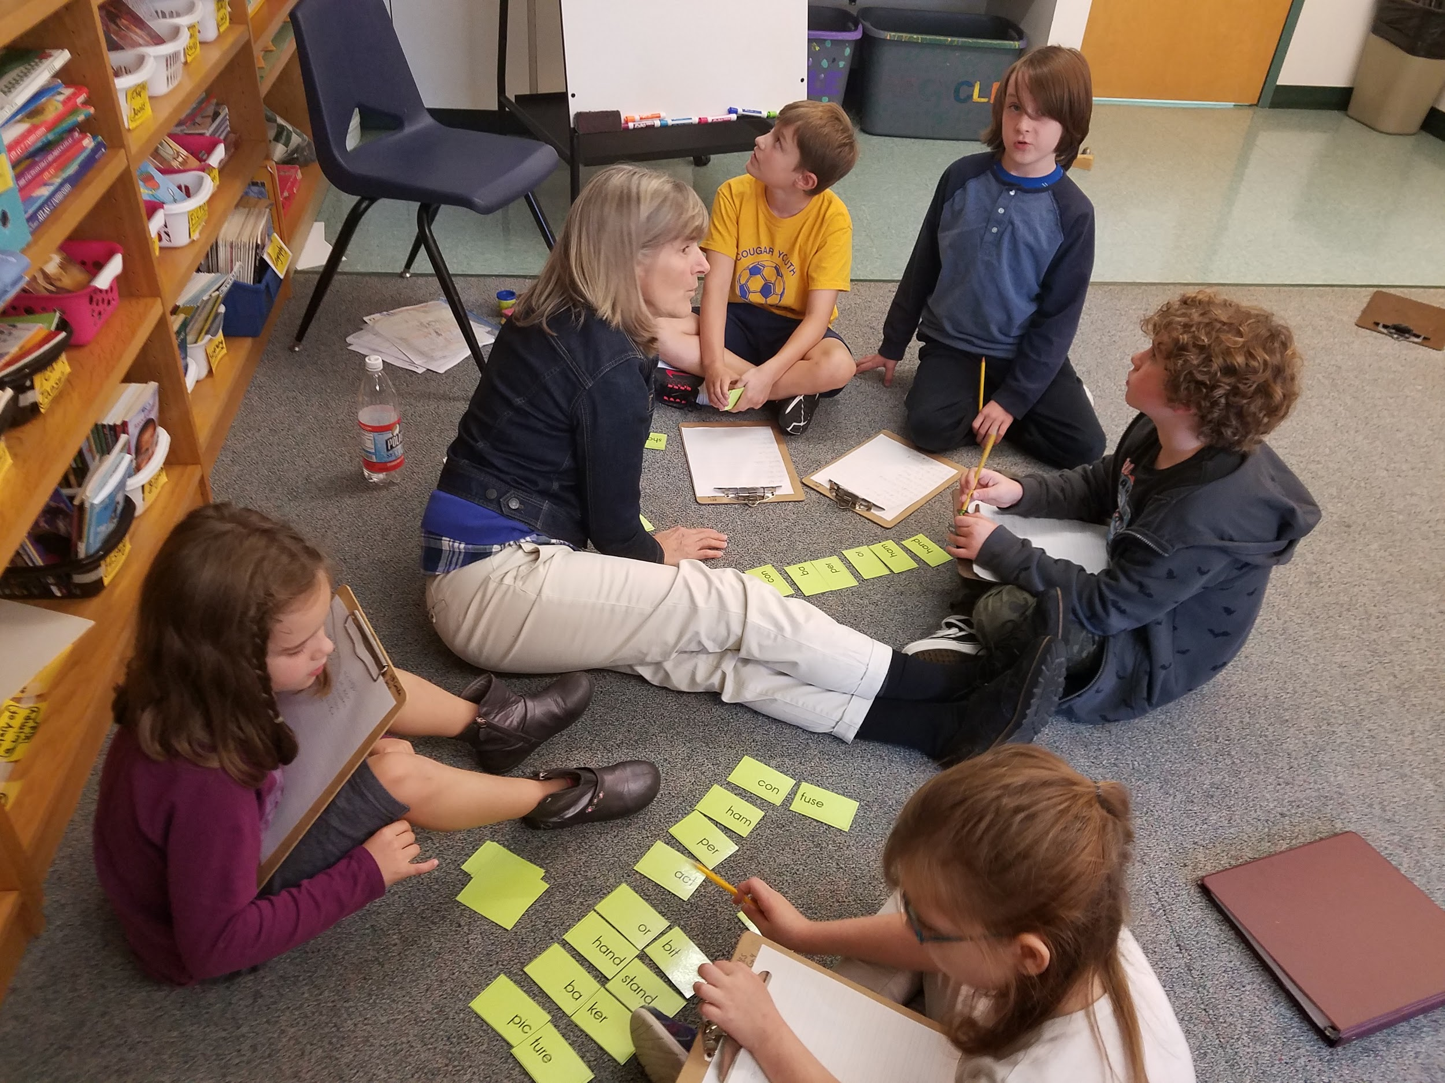
Have your children mentioned that HES is hosting a talent show? Ms. Hutchins and Ms. Carter are heading up our first HES talent show! The tentative date of the show will be Friday, November 9th during the school day. Look for flyers explaining the process.
We have had a number of families reach out to share their ideas and opinions related to homework, family time, individuality, and kindness. I am so excited that families are voicing their philosophies and sharing their ideas. I invite you to join our Leadership Team where we can work together to develop agreed upon practices and experiences that ensure all students are successful academically and socially at Hancock Elementary School. Our Leadership Team meets on the third Wednesday of the month at 3:30 pm. Our next meeting is scheduled for Wednesday, October 17th. Please email or call me if you would like to be a part of the team. Thank you to Liz Cohen for continuing with the team this year. If you would like to be part of the team but can not make the day/time, please contact me and we will see what we can do!
Our special this week is Library/Media with Mr. Kendall.
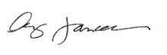
Have a wonderful week!

