Dear Parents and Guardians,
I’d like to take a moment to wish you and your family a happy and restful holiday. You have worked hard to support your child(ren) with their learning adventure at HES. Ensuring that your children are clean, well fed, dressed properly for the weather, and calm is no easy task - well done! Your children are thriving at HES because of your care and commitment to education.

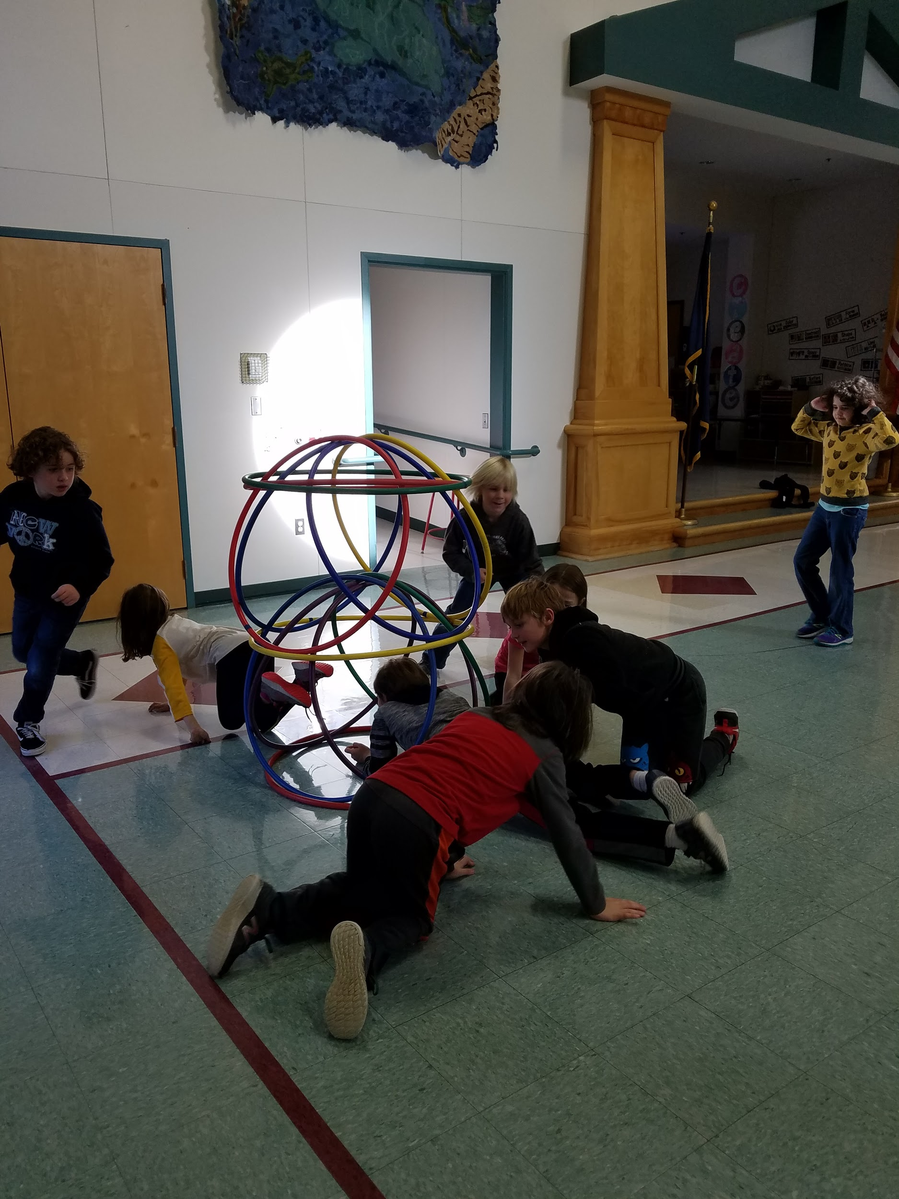
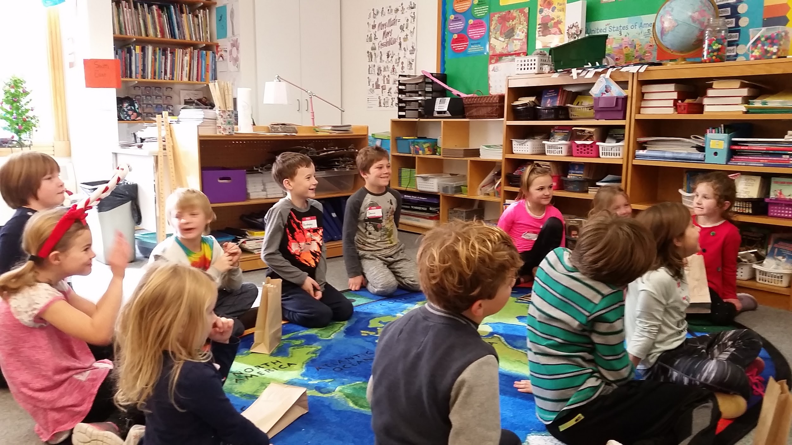
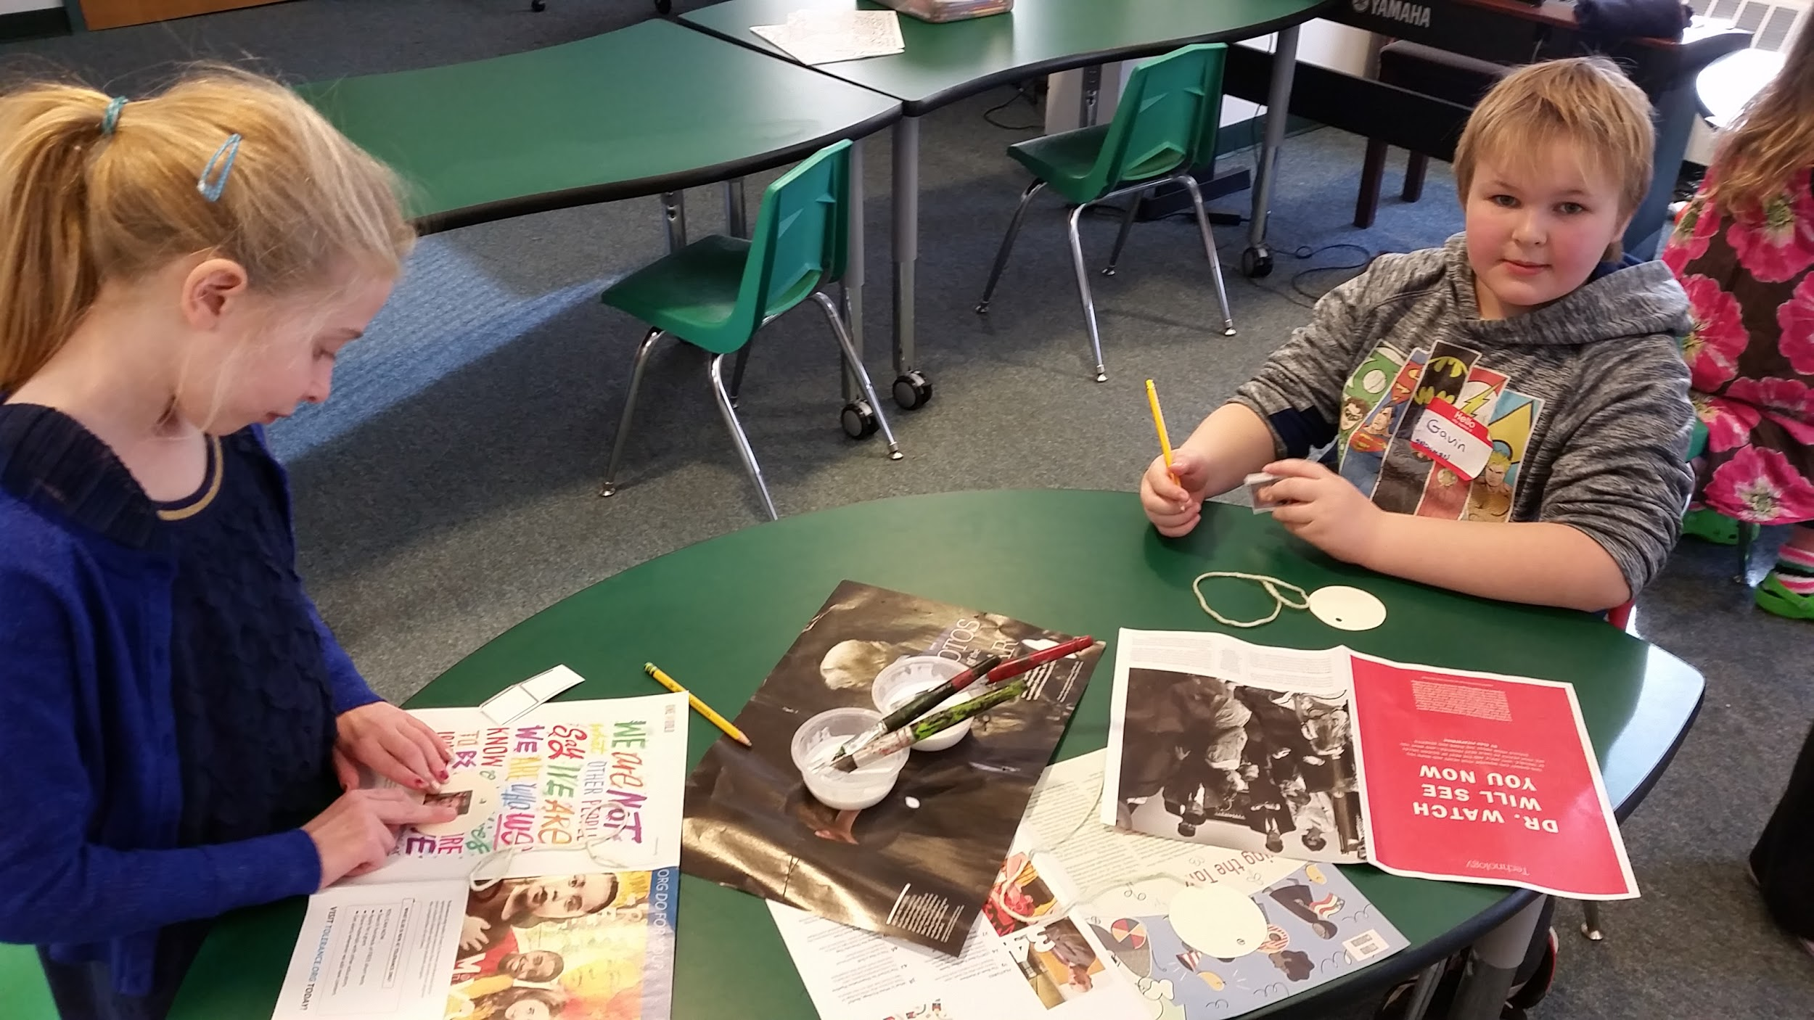
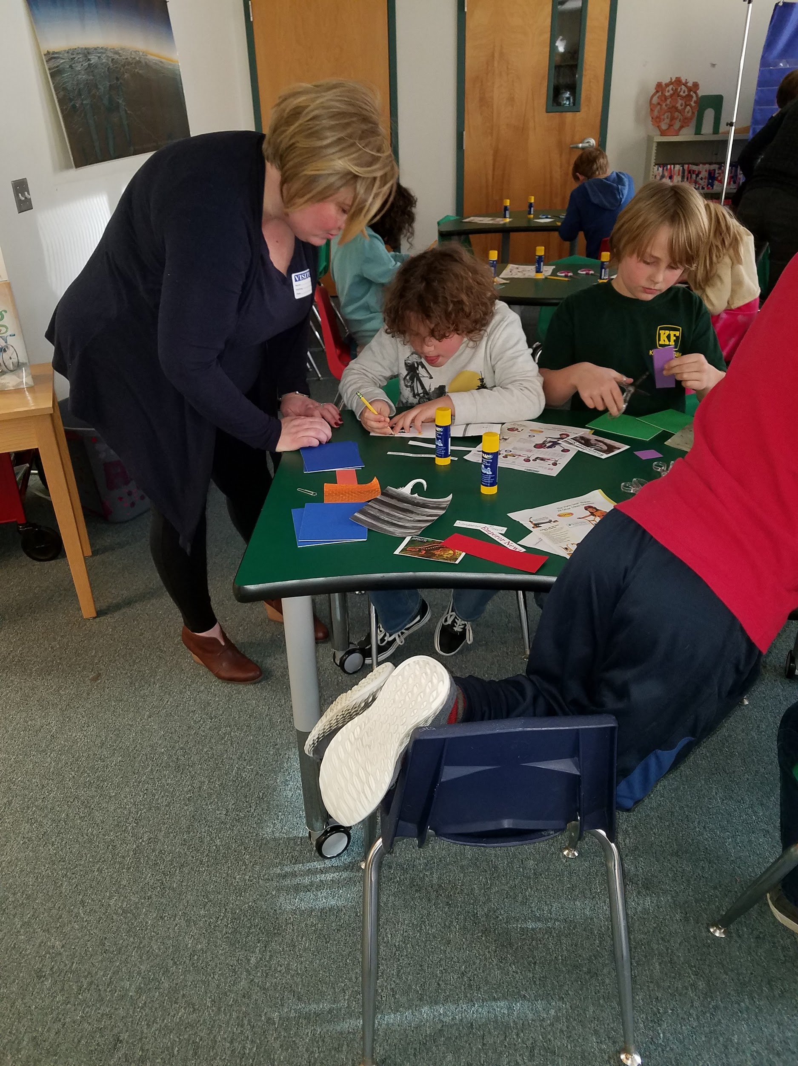

I look forward to many new adventures for 2019. Please take a look at the January Calendar for upcoming events (turn over).
Happy New Year!
