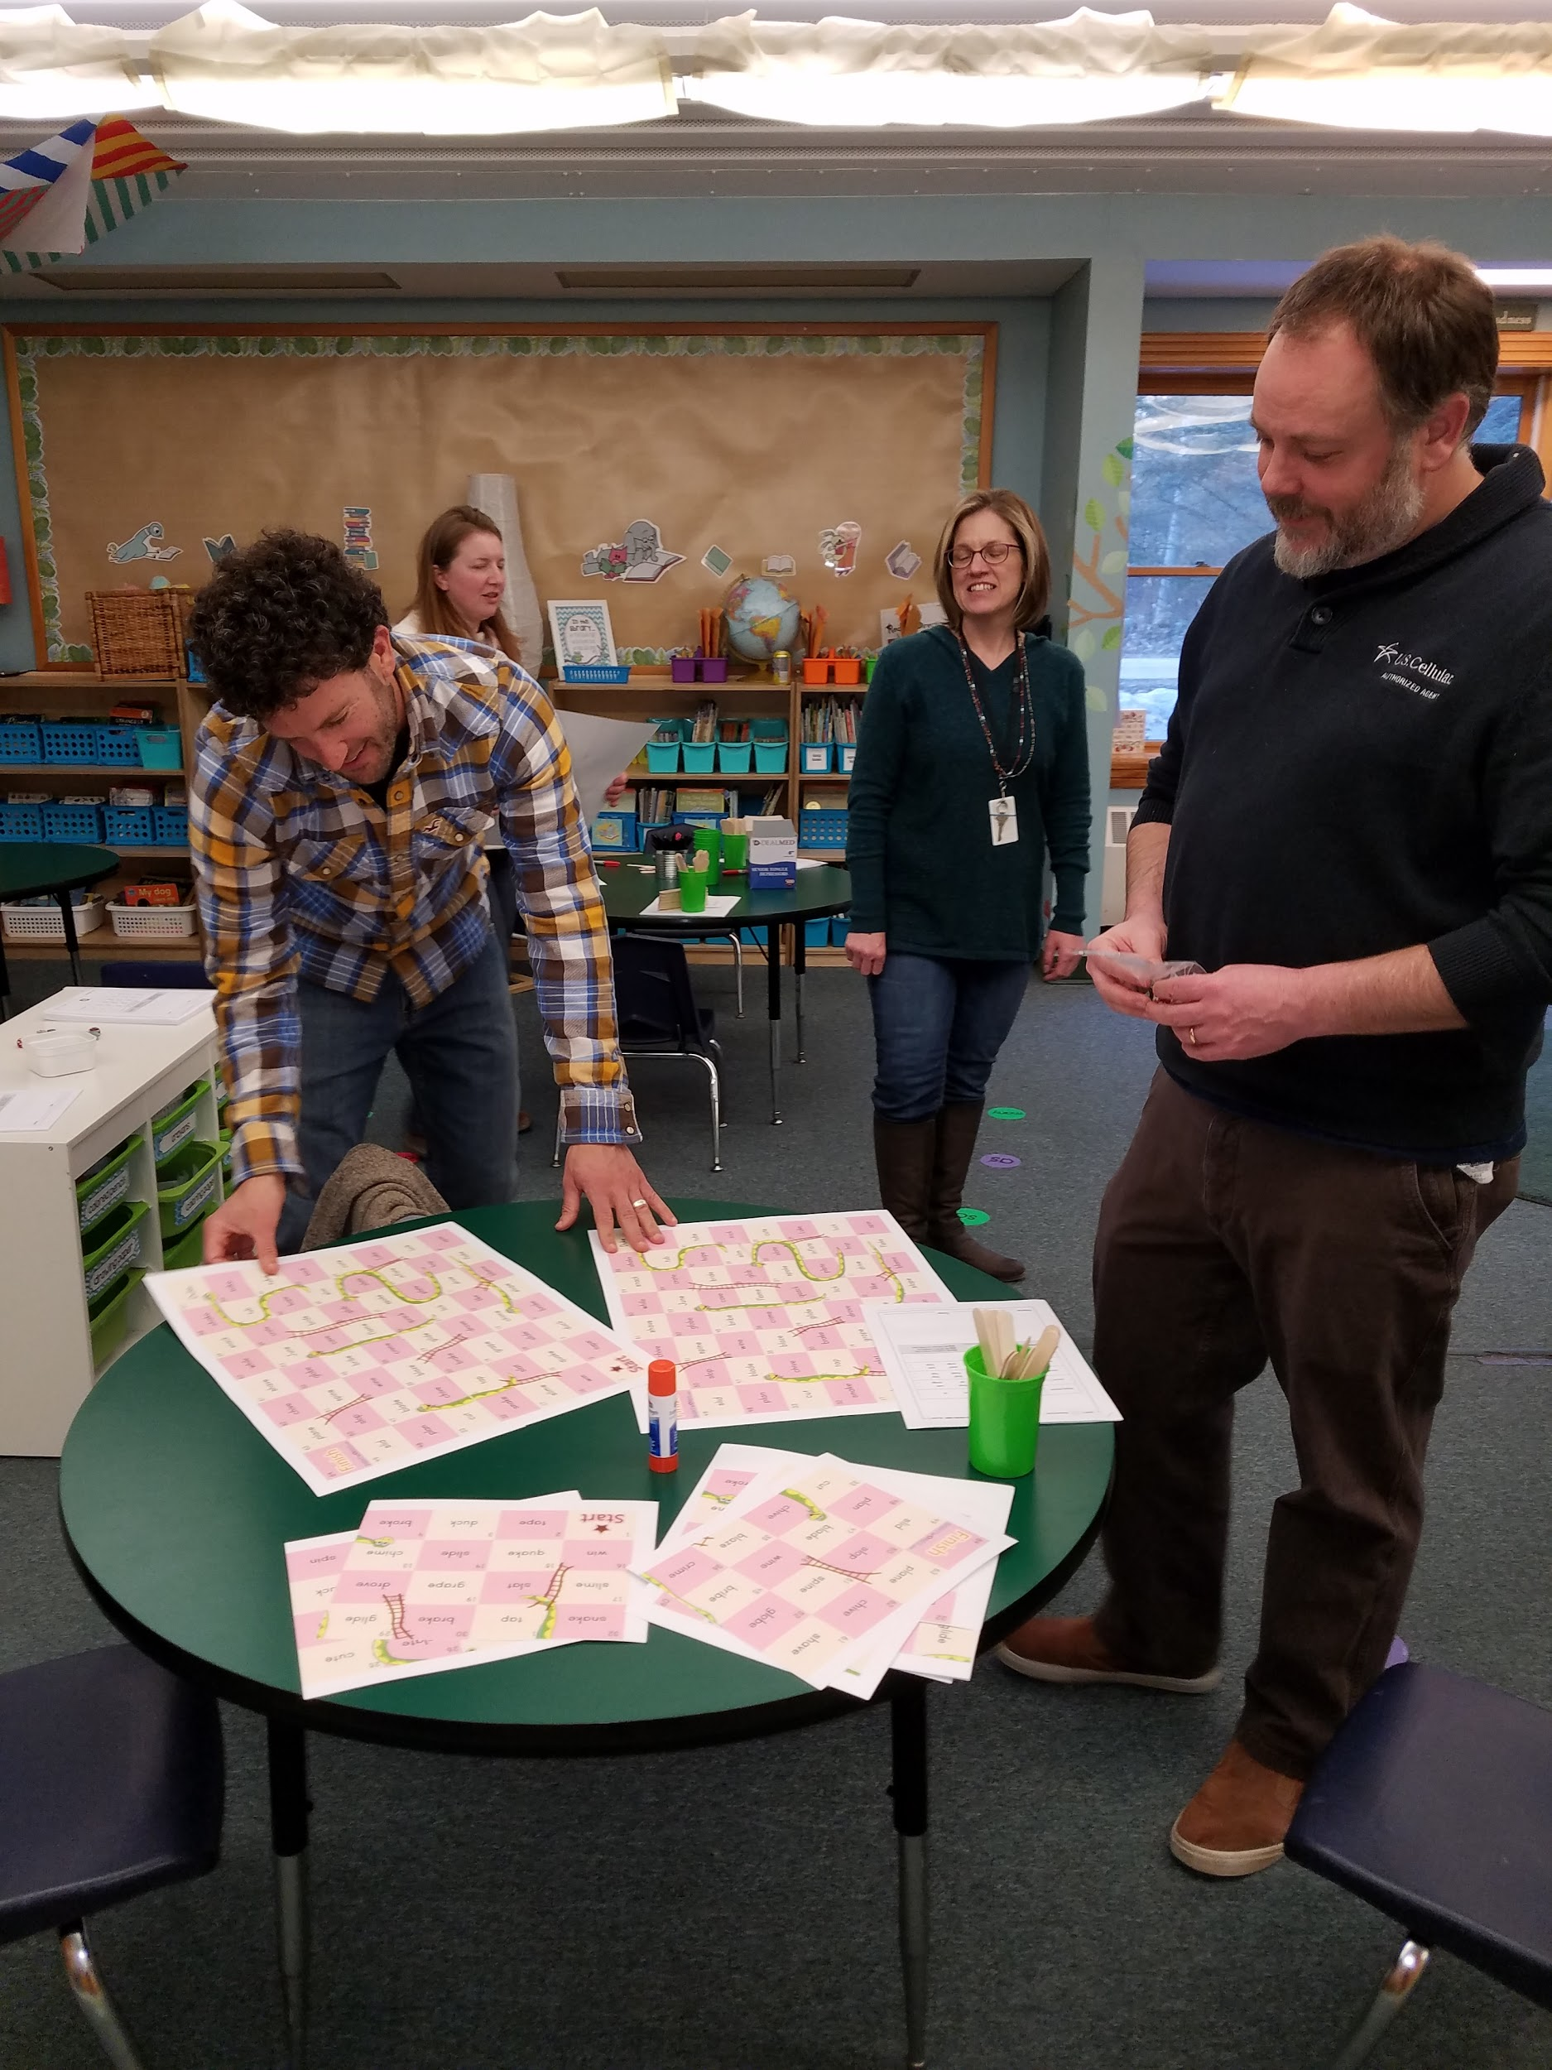
Happy Spring!
Thank you for attending our second Literacy Night for Parents. It was wonderful to see so many parents engage in learning to benefit their children. I strongly believe that HES children will succeed academically and socially because of our teamwork!
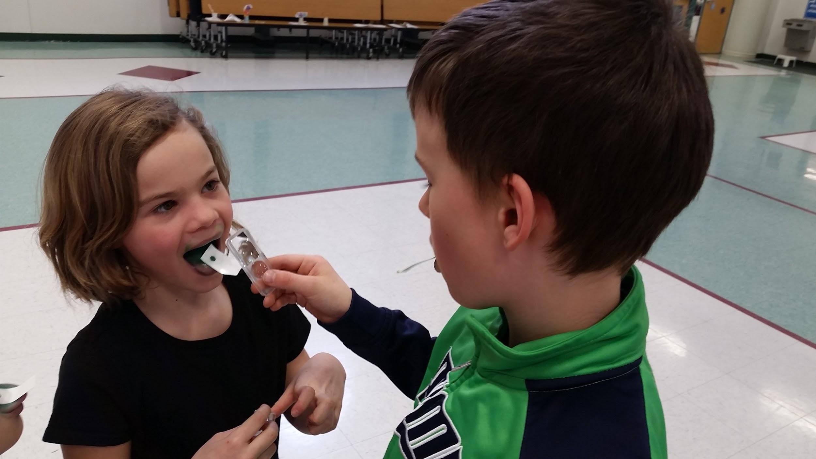
Science day was a hit! The children had fun exploring structures, senses, and habitats. Even the adults learned something new. Did you know that if you have a larger number of taste buds on your tongues you likely are more sensitive to spicy food?!
If your child is in grades 1-4, you will find NWEA/MAP winter results attached. As you may remember from the fall, your child’s MAP results are reported in RIT scores. The RIT score is an equal-interval scale, like feet and inches, that is independent of grade level. As a result, we can accurately measure students’ growth in between tests and understand if they are performing on, above, or below grade level. Please review the results and, if needed, connect with your child’s teacher to better understand the results.
Girls on the Run for our third and fourth grade girls begins this week. Our first practice will be on Tuesday, March 26th. We will meet from 3:45-5:15 every Tuesday and Thursday at GES until June 6th. The 5K celebration is on Saturday, June 8th. HES participants will take the after school program bus to GES. Parents are responsible for pick up at 5:15.
Don’t forget to return your child’s permission slip for our all school trip the Capitol Center to see Rosie Revere Engineer. Please call Ms. Carter if you need a new permission slip.
The PTO is accepting donations for the May 4th Kiwanis Yard sale. They are in need of clean, sellable items to be donated to the Hancock Elementary School PTO. Books, toys, housewares, bric-a-brac.... All proceeds from the sale of these items will directly benefit HES children. Please call or text Karie @ 860.882.9315 to arrange drop off or a small pickup. Items can be dropped off between April 6th and May 3rd.
This week your children will begin preparing for our Spring Music Concert. Ms. Pineau will be teaching the children various songs throughout the week. When she returns in May, she will put the final touches on the concert for an afternoon concert. Stay tuned for details.
Enjoy your week.

