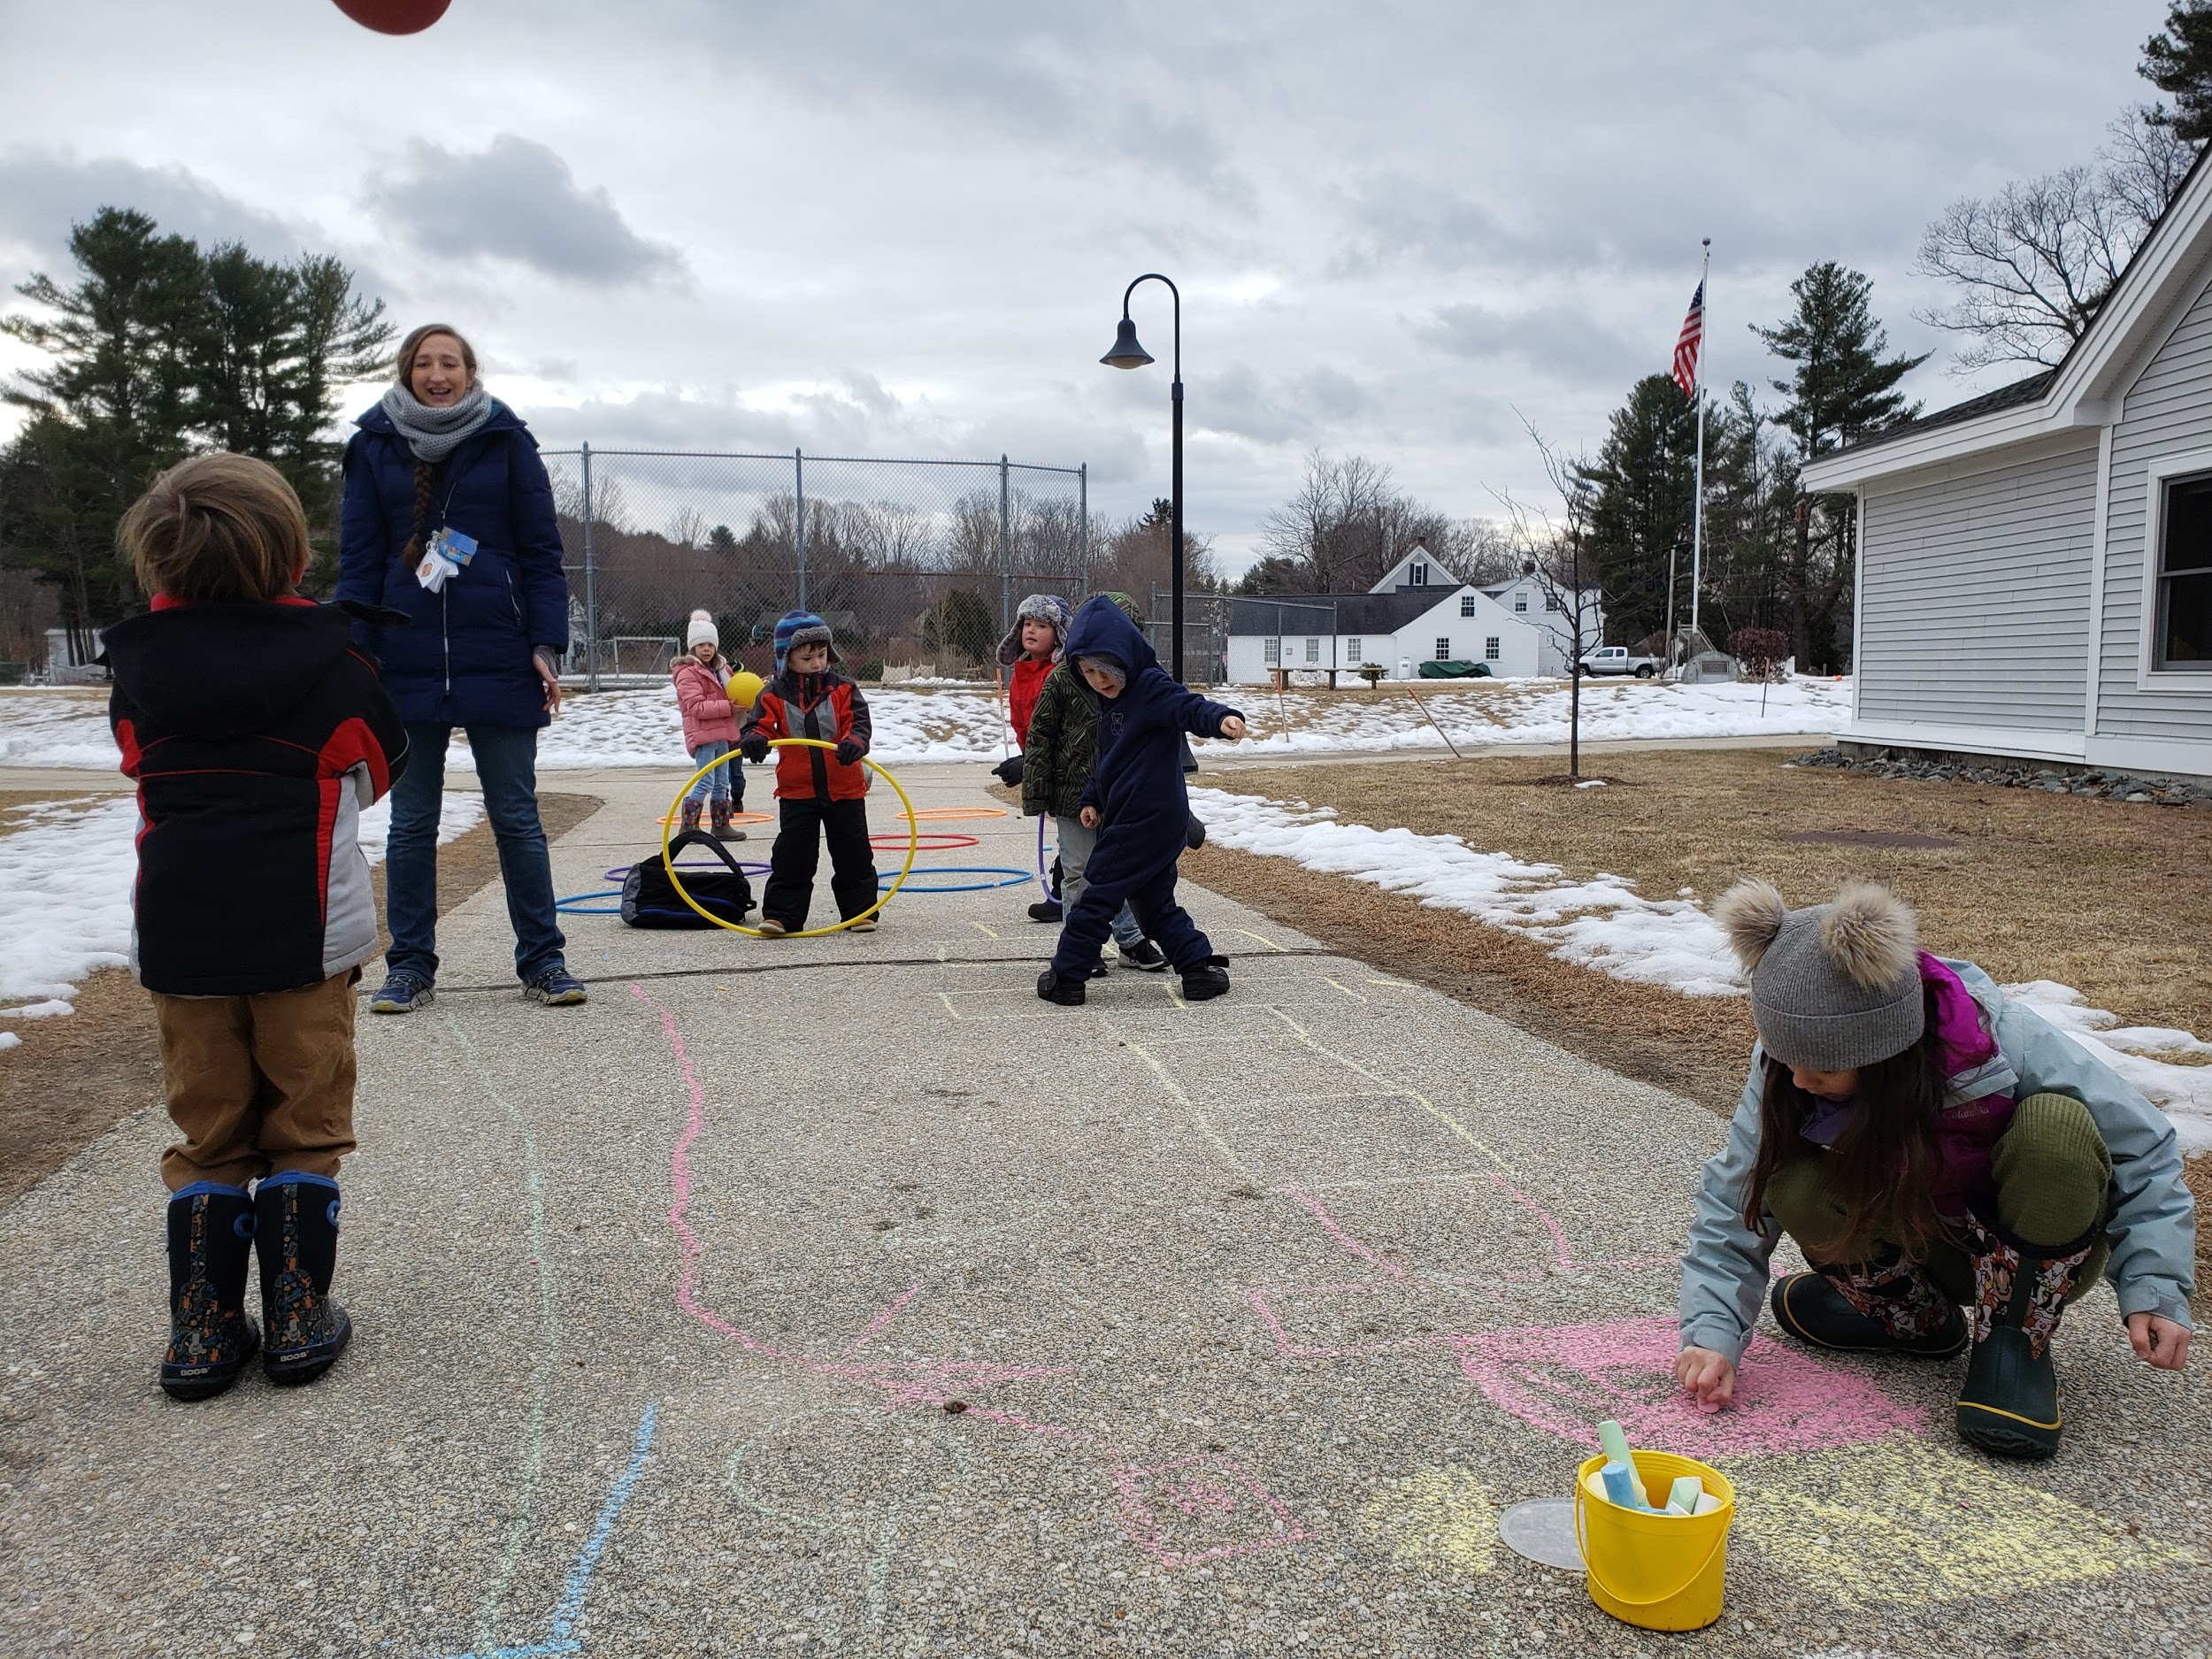
Happy Mud Season!

I guess the fact that your children’s clothing is full of mud is a sign that they are out, playing and happy!!!! With the warm sun, the children are dying to head out with minimal clothing. However, there is still a chill in the air and snow on the ground. Please continue to send your children in with boots, coats, and snow pants or rain pants. I would also recommend sending a change of pants and socks on a daily basis (all ages). The wet snow soaks right through the snow pants.

We are excited to have Troy Wunderle join us for a Circus Residency next week. He will work with Mrs. Parker during PE. Please join us for assembly on Friday at 11:20 (slightly earlier than usual) where students will showcase their new talents.
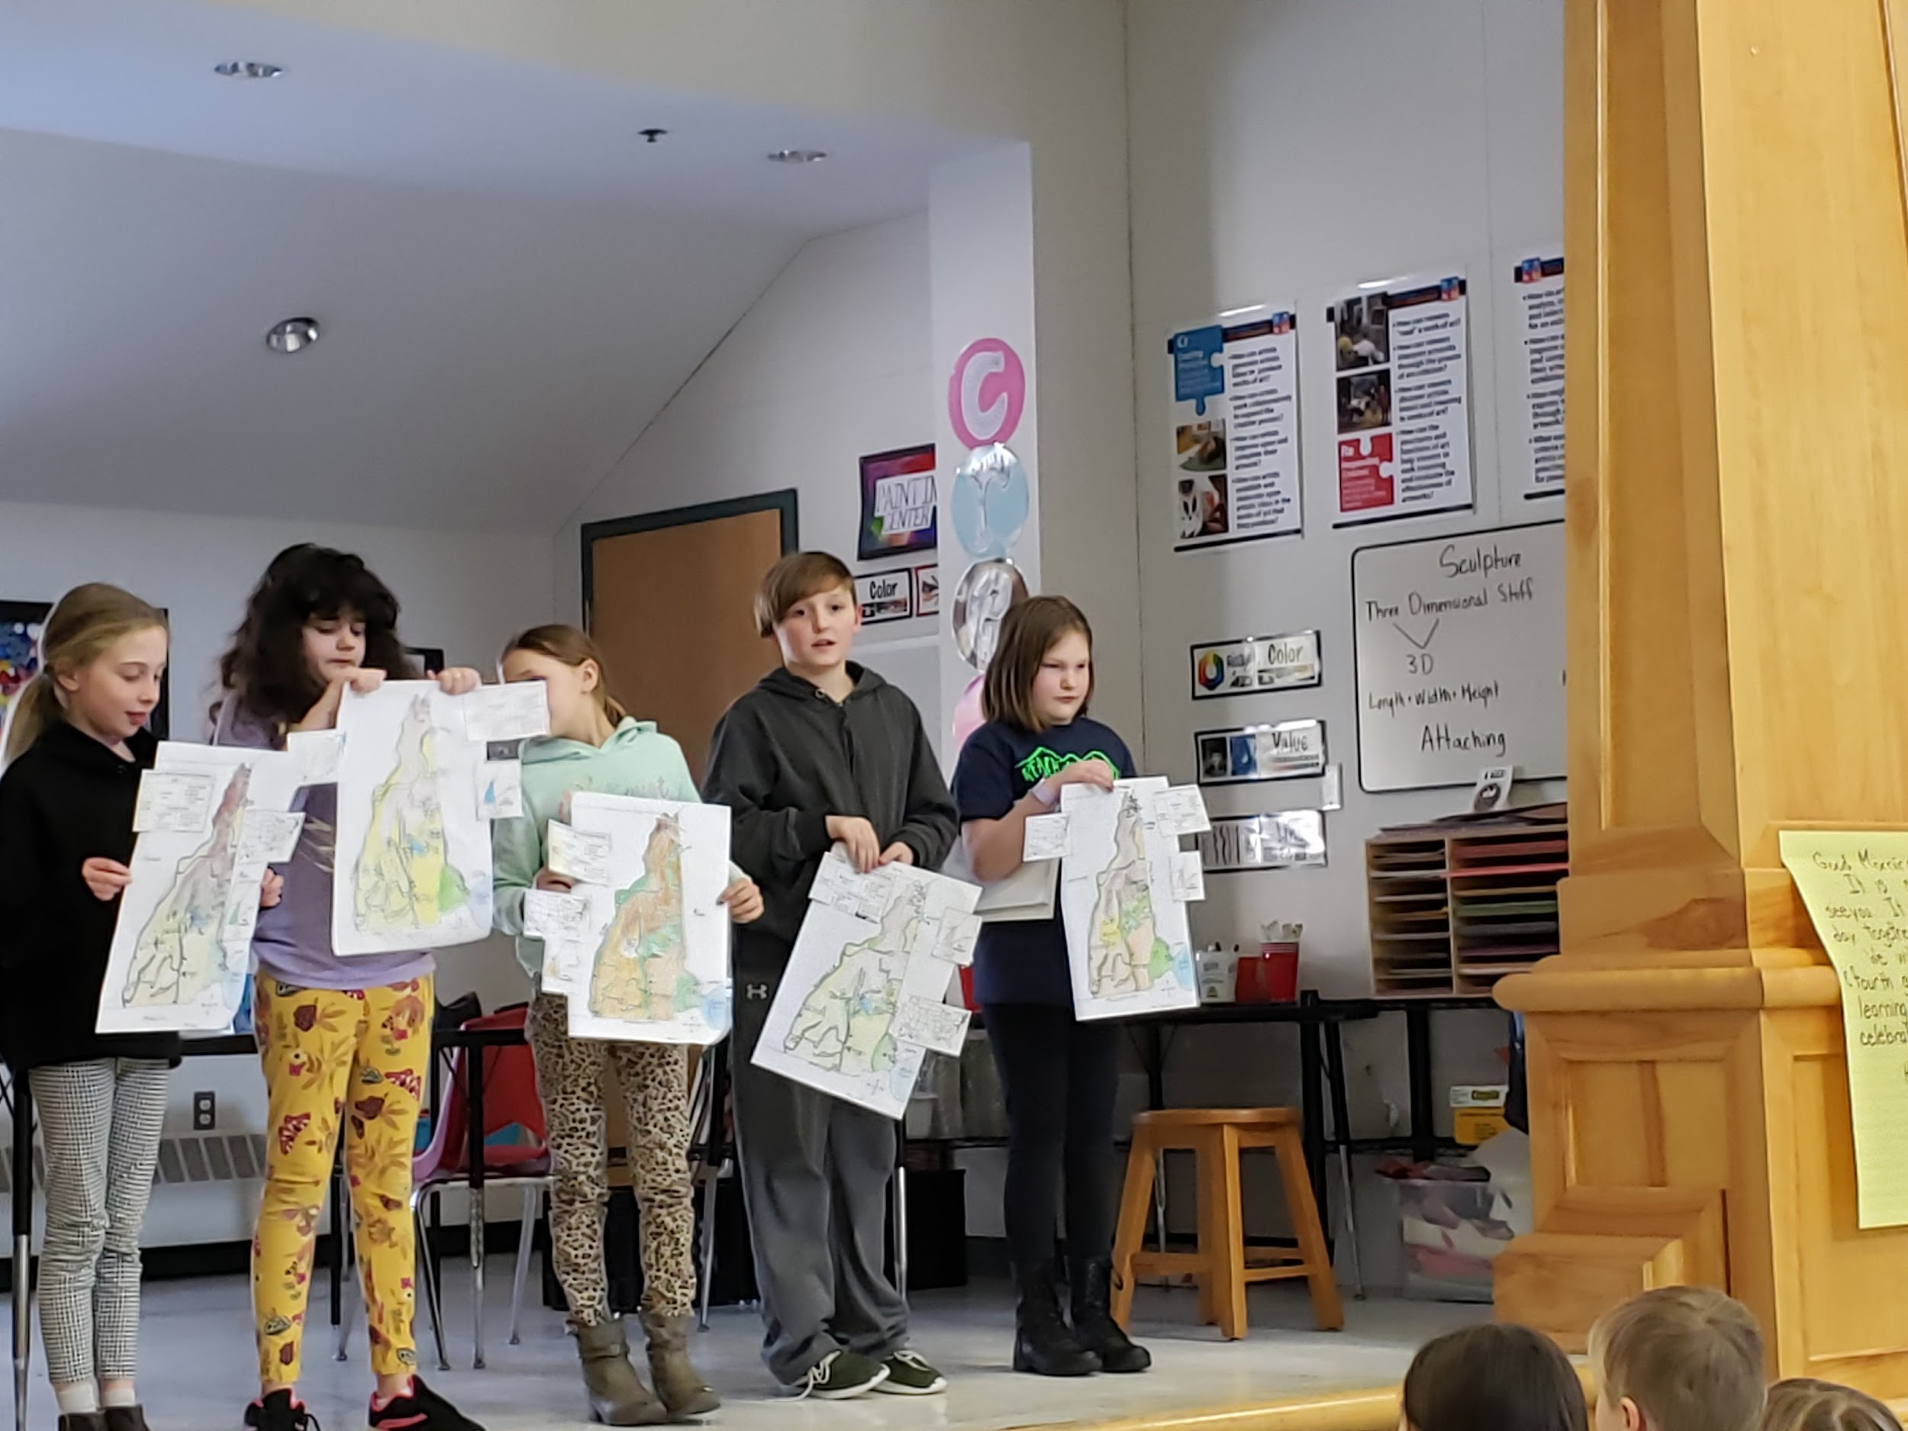
Just a heads up, because of the lack of snow, the Winter Frolic has been postponed until next Sunday, March 15th. The PTO hopes to be able to organize alternative activities if there is no snow.

HES will host a Math Night on Wednesday, March 18th from 5pm - 6pm. Math Night is an opportunity to see how HES staff and students are progressing in meeting our annual math goal. Following a presentation by Mrs. Janoch, parents will head to his/her child’s classroom. Classroom teachers will present information about Eureka, answer questions, as well as teach adults activities that can be done at home to assist the children with making progress in math! Childcare will be provided as well as pizza and drinks. Watch for a survey to determine a headcount for ordering pizza.

March events:
- Circus Residency: March 9th - 13th during PE class
- Circus Showcase: March 13th at 11:30am (possibly 11:20 start)
- No School March 10th
- Budget Voting Day March 10th
- Winter Frolic sponsored by the PTO: Sunday, March 15th 11am - 3pm
- State House and WMUR Field Trip: March 17th 3rd and 4th graders
- Math Night for Parents: March 18th, 5 - 6pm Pizza and Childcare provided

Have a wonderful weekend.

